WORKERS COMPENSATION – FIRST REPORT OF INJURY OR ILLNESS
EMPLOYER (NAME & ADDRESS INCL ZIP)  Morehouse Parish School Board |  | CARRIER/ADMINISTRATOR CLAIM NUMBER | OSHA LOG NUMBER | REPORT PURPOSE CODE
P O Box 872  Bastrop, LA 71221 |  | JURISDICTION | JURISDICTION CLAIM NUMBER
 |  | INSURED REPORT NUMBER
 |  | EMPLOYER’S LOCATION ADDRESS (IF DIFFERENT) |  | LOCATION #
INDUSTRY CODE | EMPLOYER FEIN  72-6000917 | 4099 Naff Avenue, Bastrop, | LA 71220 | PHONE #
CARRIER/CLAIMS ADMINISTRATOR
CARRIER (NAME, ADDRESS, & PHONE #) POLICY PERIOD CLAIMS ADMINISTRATOR (NAME, ADDRESS & PHONE NO)

LUBA Worker's Comp P O Box 98082

8/1/22

TO 7/31/23
LUBA Worker's Compensation P O Box 98082

Baton Rouge, LA 70898-9082
CARRIER FEIN POLICY/SELF-INSURED NUMBER
028000018442121
CHECK IF APPROPRIATE

SELF INSURANCE
Baton Rouge, LA 70898-9082
(225) 389-5822
ADMINISTRATOR FEIN

AGENT NAME & CODE NUMBER

EMPLOYEE/WAGE
NAME (LAST, FIRST, MIDDLE) DATE OF BIRTH SOCIAL SECURITY NUMBER DATE HIRED STATE OF HIRE

ADDRESS (INCL ZIP)
SEX

M MALE
MARITAL STATUS

UNMARRIED SINGLE/DIVORCED
U
OCCUPATION/JOB TITLE

EMPLOYMENT STATUS

F FEMALE
U UNKNOWN
M MARRIED
S SEPARATED

PHONE
# OF DEPENDENTS
K UNKNOWN
NCCI CLASS CODE

RATE PER:

OCCURRENCE/TREATMENT
DAY WEEK
MONTH
OTHER:
DAYS WORKED/WEEK
FULL PAY FOR DAY OF INJURY? DID SALARY CONTINUE?
YES NO
YES NO

TIME EMPLOYEE BEGAN WORK
AM DATE OF INJURY/ILLNESS PM
TIME OF OCCURRENCE

( ) CANNOT BE DETERMINED
AM LAST WORK DATE PM
DATE EMPLOYER NOTIFIED
DATE DISABILITY BEGAN

CONTACT NAME/PHONE NUMBER
TYPE OF INJURY/ILLNESS
PART OF BODY AFFECTED

DID INJURY/ILLNESS/EXPOSURE OCCUR ON EMPLOYER’S PREMISES?
TYPE OF INJURY/ILLNESS CODE
PART OF BODY AFFECTED CODE

YES NO

DEPARTMENT OR LOCATION WHERE ACCIDENT OR ILLNESS EXPOSURE OCCURRED
ALL EQUIPMENT, MATERIALS, OR CHEMICALS EMPLOYEE WAS USING WHEN ACCIDENT OR ILLNESS EXPOSURE OCCURRED

SPECIFIC ACTIVITY THE EMPLOYEE WAS ENGAGED IN WHEN THE ACCIDENT OR ILLNESS EXPOSURE OCCURRED
WORK PROCESS THE EMPLOYEE WAS ENGAGED IN WHEN ACCIDENT OR ILLNESS EXPOSURE OCCURRED

HOW INJURY OR ILLNESS/ABNORMAL HEALTH CONDITION OCCURRED. DESCRIBE THE SEQUENCE OF EVENTS AND INCLUDE ANY OBJECTS OR SUBSTANCES THAT DIRECTLY INJURED THE EMPLOYEE OR MADE THE EMPLOYEE ILL
CAUSE OF INJURY CODE

DATE RETURN(ED) TO WORK
IF FATAL, GIVE DATE OF DEATH
WERE SAFEGUARDS OR SAFETY EQUIPMENT PROVIDED? WERE THEY USED?
YES NO
YES NO

PHYSICIAN/HEALTH CARE PROVIDER (NAME & ADDRESS)
HOSPITAL OR OFF SITE TREATMENT (NAME & ADDRESS)
INITIAL TREATMENT
0 NO MEDICAL TREATMENT

1 MINOR: BY EMPLOYER

OTHER
WITNESSES (NAME & PHONE #)

- MINOR CLINIC/HOSP
- EMERGENCY CARE
- HOSPITALIZED > 24 HOURS
FUTURE MAJOR MEDICAL/ LOST TIME ANTICIPATED
5

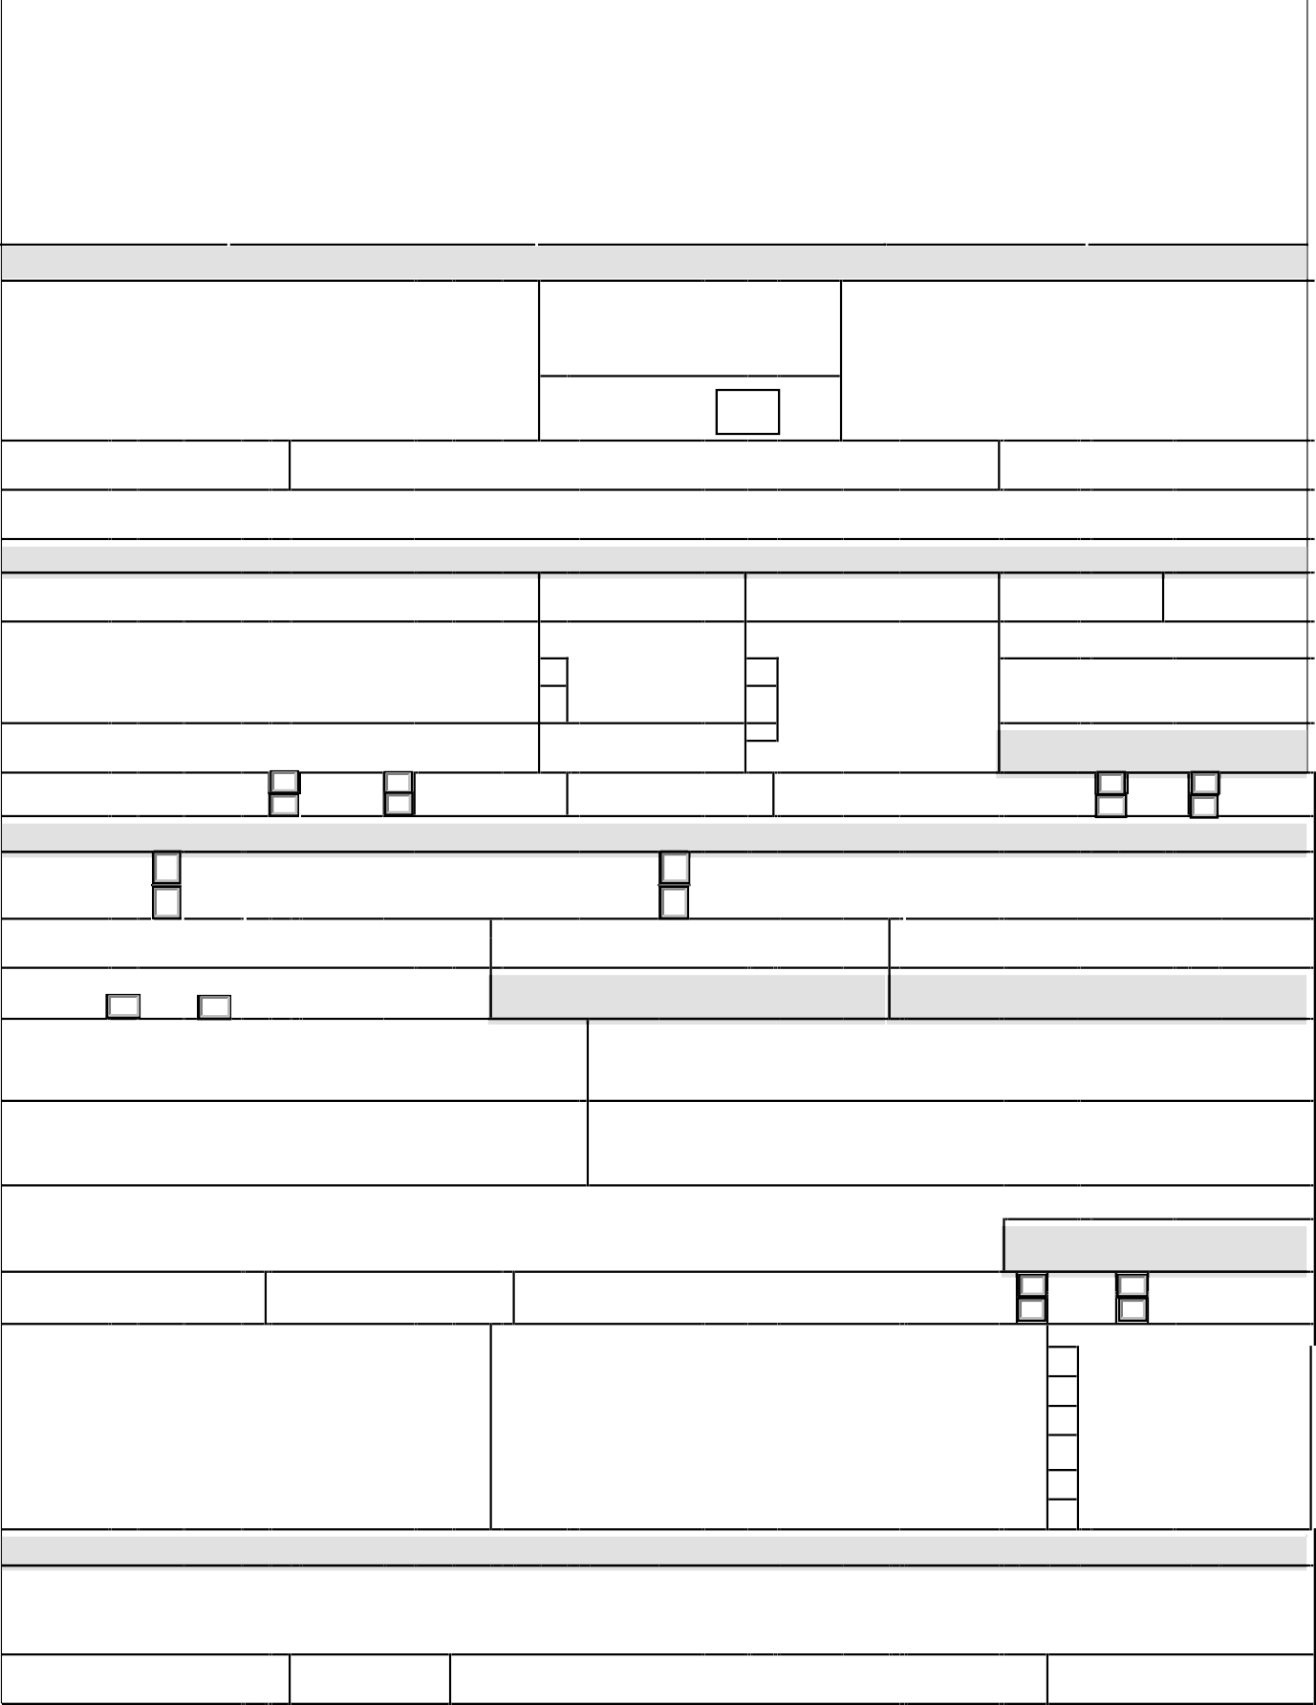
DATE ADMINISTRATOR NOTIFIED

LWC-WC IA-1
DATE PREPARED
PREPARER’S NAME & TITLE
PHONE NUMBER

IAIABC 2002

EMPLOYER’S INSTRUCTIONS

DO NOT ENTER DATA IN SHADED FIELDS

DATES:
Enter all dates in MM/DD/YY format.

INDUSTRY CODE:
This is the code which represents the nature of the employer’s business, which is contained in the Standard Industrial Classification Manual or the North American Industry Classification System, published by the Federal Office of Management and Budget.

CARRIER:
The licensed business entity issuing a contract of insurance and assuming financial responsibility on behalf of the employer of the claimant.
CLAIMS ADMINISTRATOR:
Enter the name of the carrier, third party administrator, state fund, or self-insured responsible for administering the claim.
AGENT NAME & CODE NUMBER:
Enter the name of your insurance agent and his/her code number if known. This information can be found on your insurance policy.

OCCUPATION/JOB TITLE:
This is the primary occupation of the claimant at the time of the accident or exposure.
EMPLOYMENT STATUS:
Indicate the employee’s work status. The valid choices are:
Full-Time | On Strike | Unknown | Volunteer
Part-Time | Disabled | Apprenticeship Full-Time | Seasonal
Not Employed | Retired | Apprenticeship Part-Time | Piece Worker

DATE DISABILITY BEGAN:
The first day on which the claimant originally lost time from work due to the occupation injury or disease or as otherwise designated by statute.
CONTACT NAME/PHONE NUMBER:
Enter the name of the individual at the employer’s premises to be contacted for additional information.

TYPE OF INJURY/ILLNESS:
Briefly describe the nature of the injury or illness, (eg. Lacerations to the forearm).

PART OF BODY AFFECTED:
Indicate the part of body affected by the injury/illness, (eg. Right forearm, lower back).

DEPARTMENT OR LOCATION WHERE ACCIDENT OR ILLNESS EXPOSURE OCCURRED: (eg.
Maintenance Department or Client’s office at 452 Monroe St., Washington, DC 26210)

If the accident or illness exposure did not occur on the employer’s premises, enter address or location. Be specific.

LWC-WC IA-1 IAIABC 2002

EMPLOYER’S INSTRUCTIONS – cont’d

ALL EQUIPMENT, MATERIAL OR CHEMICALS EMPLOYEE WAS USING WHEN ACCIDENT OR ILLNESS EXPOSURE OCCURRED:
(eg. Acetylene cutting torch, metal plate)

List all of the equipment, materials, and/or chemicals the employee was using, applying, handling or operating when the injury or illness occurred. Be specific, for example: decorator’s scaffolding, electric sander, paintbrush, and paint.
Enter “NA” for not applicable if no equipment, materials, or chemicals were being used. NOTE: The items listed do not have to be directly involved in the employee’s injury or illness.
SPECIFIC ACTIVITY THE EMPLOYEE WAS ENGAGED IN WHEN THE ACCIDENT OR ILLNESS EXPOSURE OCCURRED:
(eg. Cutting metal plate for flooring)

Describe the specific activity the employee was engaged in when the accident or illness exposure occurred, such as sanding ceiling woodwork in preparation for painting.
WORK PROCESS THE EMPLOYEE WAS ENGAGED IN WHEN ACCIDENT OR ILLNESS EXPOSURE OCCURRED:
Describe the work process the employee was engaged in when the accident or illness exposure occurred, such as building maintenance. Enter “NA” for not applicable if employee was not engaged in a work process (eg. walking along a hallway).

HOW INJURY OR ILLNESS/ABNORMAL HEALTH CONDITION OCCURRED. DESCRIBE THE SEQUENCE OF EVENTS AND INCLUDE ANY OBJECTS OR SUBSTANCES THAT DIRECTLY INJURED THE EMPLOYEE OR MADE THE EMPLOYEE ILL:
(Worker stepped back to inspect work and slipped on some scrap metal. As worker fell, worker brushed against the hot metal.)
Describe how the injury or illness/abnormal health condition occurred. Include the sequence of events and name any objects or substance that directly injured the employee or made the employee ill. For example: Worker stepped to the edge of the scaffolding to inspect work, lost balance and fell six feet to the floor. The worker’s right wrist was broken in the fall.
DATE RETURN(ED) TO WORK:
Enter the date following to most recent disability period on which the employee returned to work.

LWC-WC IA-1

